5th November 2020 – Sarah Pix
Matthew 14: 27-32
Jesus immediately said to them: ‘Take courage! It is I. Don’t be afraid.’
‘Lord, if it’s you,’ Peter replied, ‘tell me to come to you on the water.’
‘Come,’ he said.
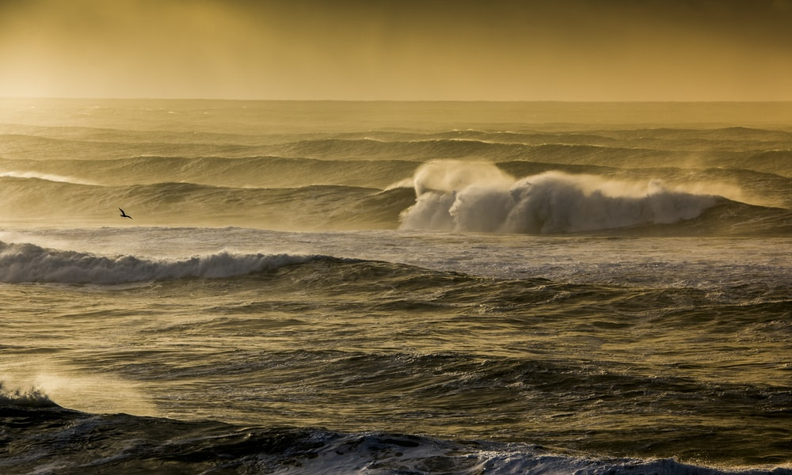
Then Peter got down out of the boat, walked on the water and came towards Jesus. But when he saw the wind, he was afraid and, beginning to sink, cried out, ‘Lord, save me!’
Immediately Jesus reached out his hand and caught him. ‘You of little faith,’ he said, ‘why did you doubt?’
And when they climbed into the boat, the wind died down.

Do you ever get that sinking feeling? Sometimes in life, we feel that wave after wave of difficulties are sweeping over us, so much so that it is hard for us to snatch a breath between them. We feel overwhelmed, out of our depth. Perhaps that is our experience of hearing the news that the UK will be entering into a further lockdown, after we have already had so much to contend with over the year.
I take great comfort from the story of Peter walking on the water. He had stepped in obedience to His Master’s command, but then as he takes his eyes off of Jesus, the doubts begin to swirl around in his head, and the waves seem bigger, more powerful and threatening than they had when he was in the boat. He realises that he is in an impossible situation! Walking on the water! Instead of focussing on who it is that calls him to walk, he lets the waves mess with his head and starts to sink. BUT Jesus immediately comes to his aid and catches him.
As we continue in this challenging time it can be easy to focus on the wind and the waves, but as Christians we are called to focus on our Saviour. And if we feel that we are starting to sink, we should call out to the Lord to save us – He will not fail.

Listen to this to encourage you today:
https://youtu.be/N2PNTq_-mZs

Lord Jesus, we praise you as the one who is strong to save. We pray for your help as we walk through this storm. Help us to fix our eyes on you and not to be distracted by the wind and the waves. Amen

