Monday 22nd June

Luke 19: 2 – 4

A man was there by the name of Zacchaeus; he was a chief tax collector and was wealthy. He wanted to see who Jesus was, but because he was short he could not see over the crowd. So he ran ahead and climbed a sycamore-fig tree to see him, since Jesus was coming that way.

I remember when we first met our dog Rosie. I clearly remember saying to the girls, ‘we are not going to buy a puppy today – we are just going to have a look’. Sometimes we want to check something out before we commit to it. Of course, we came home with a puppy! I love the story of Zacchaeus. He wanted to check Jesus out, but he wasn’t sure that he wanted to commit. He didn’t want to get lost in the crowd. More than that, I expect he wasn’t at all sure whether he would be welcome. Would Jesus reject him like just about everyone else he had known? But his curiosity got the better of him! He had to see Jesus, and so he did it in a way which he thought he could remain anonymous. But Jesus can’t resist a heart that is seeking Him! And as Jesus came by, He sees Zacchaeus and calls him down. Zacchaeus’ life was utterly turned around that day! I was talking to a friend recently who said that this period of our history has shown that there are lots of people out there like Zacchaeus. They are curious about Jesus. They want to take a look but are not sure whether they will be welcomed. Online services across the country are being viewed by vast numbers of people – perhaps these services are a bit of a Sycamore tree! Maybe you are reading this today and you feel like Zacchaeus. Well Jesus sees you and He loves you. He calls your name today. He is inviting you into the adventure of knowing Him! What do you think?

Lord Jesus, thank you that you see us, that you know us and that you love us. We pray today for any that are sensing your call and pray that you would give them courage to respond. We pray that as your people we would always reach out with your love and help people to take the next step with you. As our church building opens today for private prayer, we pray that we would be a demonstration of how good you are, and what a transformative thing it is to know you. For your name’s sake. Amen

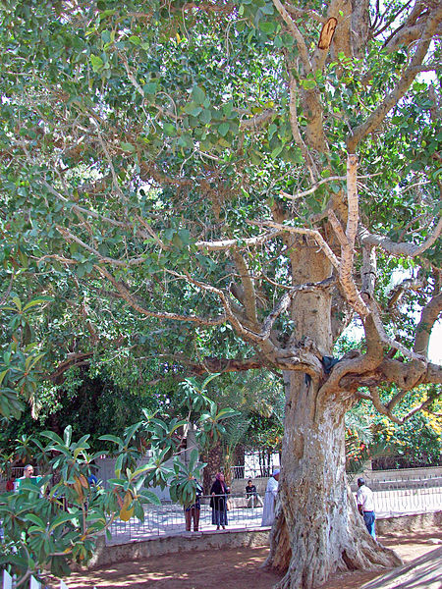

This tree stands at a major intersection in Jericho. Although the tree may not be the same one Zacchaeus climbed local tradition has named it Zacchaeus tree.
Tests carried out on the tree have shown that it is over 2,000 years old and it stands in the same setting as the Biblical sycamore tree.

