Monday 15th June

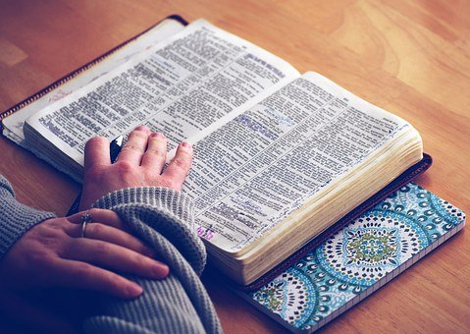
Philippians 2: 2 – 7
Make my joy complete by being like-minded, having the same love, being one in spirit and of one mind. Do nothing out of selfish ambition or vain conceit. Rather, in humility value others above yourselves, not looking to your own interests but each of you to the interests of the others. In your relationships with one another, have the same mindset as Christ Jesus: who, being in very nature God, did not consider equality with God something to be used to his own advantage; rather, he made himself nothing by taking the very nature of a servant,
being made in human likeness.

This passage blows my mind every time I read it! Jesus – High King of Heaven, One with the Father, God incarnate, through whom all things were made, puts aside His glory and honour and the 24-7 worship of the whole of heaven, and makes himself nothing. Mostly we see people clamouring for status, power and prestige. Sometimes having those things leads to entitlement. All of us want to be well thought of. But Jesus – never has the world witnessed such extraordinary humility and love. Because it was His love for you and me that compelled Him to do it. It was the only way that He could rescue humanity and restore our relationship. Allow yourself to be staggered again today by the heart of Jesus, that he would take the nature of a servant for our sakes. And then look for opportunities to be ‘like-minded, have the same love…value others above yourselves…look to the interests others…have the same mindset as Christ Jesus’ and pray for the grace to take those opportunities. Goodness! Wouldn’t the world be a different place if we lived that way?

Father, we thank you so much for the love and humility that Jesus showed. Thank you for His willingness to make himself nothing for our sake. How we need you Lord! We pray that by your Spirit you would shape in us the character of Jesus. Give us the grace to humble ourselves, to ‘go low’ in our relationships. For your glory we pray. Amen

