9th November 2020 - Canon Barry Lomax

Joshua Chapter 1 verse 9
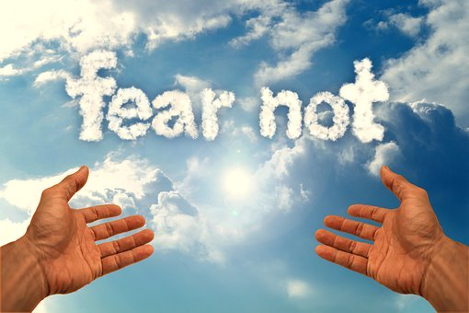

“Be strong and courageous. Do not be terrified, do not be discouraged, for the Lord your God will be with you
wherever you go.”

What were your thoughts when the Prime Minister made the announcement of a lockdown for a month again? Life seemed to be getting back to some sense of normal. But now for many there is the sense of fear, will we ever be free from Covid 19 that seems to dominate our lives. The worries of life under lockdown seem to close us in on every side and we wonder will there ever be a way out. That is why this verse from Joshua is so important. Joshua was on the edge of new life after years of wandering. But there was the worry and fear of the unknown that lay ahead. That is why God gave Joshua a pep talk and told him to rely on Him and keep looking to Him rather than the things around or ahead of him.
King George 6th in his Christmas message to the nation in 1939 with the outbreak of World War 2 and not knowing what lay ahead, quoted a poem. It was written by Minnie Louise Haskins a Wesleyan Methodist missionary and called “God knows”
“I said to the man who stood at the Gate of the Year
“Give me light that I may tread safely into the unknown”.
And he replied, “Go out into the darkness, and put your hand into the hand of God. That shall be better than light, and safer than a known way”. So I went forth and finding the hand of God, trod gladly into the night”.
In these times of uncertainty let us place our hand in the hand of God whose say’s “you are not alone”. “I will be with you wherever you go”.

“Into the hands of your love and mercy, O God our Father, I place my life this day. Give me your strength and protection and help me to know your presence with me: through Jesus Christ, Amen

Every Blessing
Barry

