Wednesday 5th August

2 Corinthians 2: 14, 15

But thanks be to God, who always leads us as captives in Christ’s triumphal procession and uses us to spread the aroma of the knowledge of him everywhere. ¹⁵ For we are to God the pleasing aroma of Christ among those who are being saved and those who are perishing.

I have the most beautiful lilies flowering in my garden at the moment! I had planted them last year, too late in the season, and they didn’t flower. I had kind of forgotten about them, and yet now here they are! Although the flowers are spectacularly large, probably the most noticeable thing about them is their gorgeous scent! It wafts through the garden, especially in the evening, and draws you to the flowers.
In these verses, Paul says that those who belong to Jesus should smell like Him! There should be something noticeable about the atmosphere we carry (in a good way!). We should stand out in such a way that others are drawn to Jesus. How can we ‘smell’ of the presence of the Lord in a time of global pandemic? Well, the first thing we can do is spend time in His presence – then His aroma will rub off on us. Then, the way in which we walk through these times, with faith, with peace, with hope will mark us as different. The ‘knowledge of Him’ is desperately needed in these times, and we have the privilege of carrying just that.

Lord, thank you that you invite us into your presence. Help us to accept that invitation, to abide with you. And as we do, we ask that we will carry your fragrance in a broken world. We pray that even as we walk along the street, people will sense your presence, even if they don’t recognise it as you to begin with. Amen

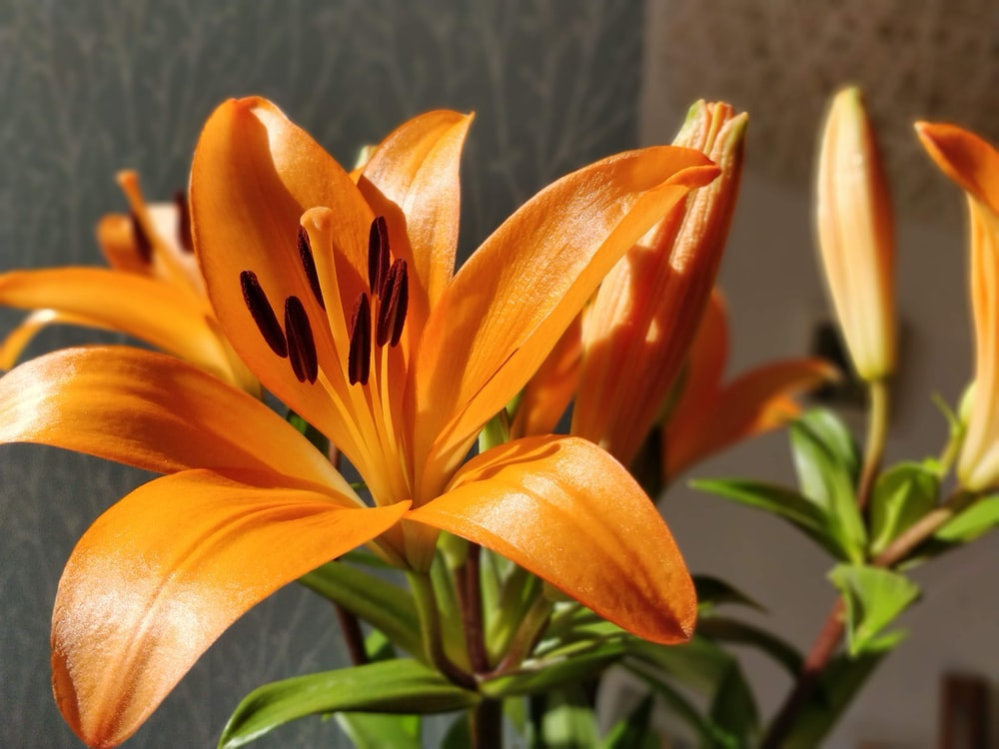
‘we ask that we will carry your fragrance in a broken world’

