Daily Prayer & Encouragement - Monday 14th December

Isaiah: 6, 7

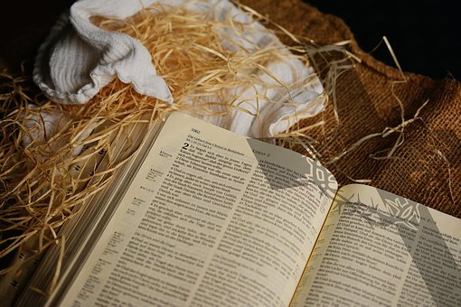
For to us a child is born,
to us a son is given,
and the government will be on his shoulders.
And he will be called Wonderful Counsellor, Mighty God, Everlasting Father,
Prince of Peace.
Of the greatness of his government and peace there will be no end.
He will reign on David’s throne and over his kingdom, establishing and upholding it with justice and righteousness
from that time on and for ever.
The zeal of the LORD Almighty will accomplish this.

What’s in a name? Well it turns out, quite a lot! I wonder whether you have been enjoying the Names of Jesus Advent Calendar that we are sending out? Jesus is given many names in the Bible, and each one says something about His character and what He came to do. In this passage from Isaiah, we see a rescuer foretold. We know that he will come as a child, but that this Son would bear the weight of the Government of the Kingdom of God, and then Isaiah gives us this tremendous list of names: Wonderful Counsellor, Mighty God, Everlasting Father, Prince of Peace. Spend some time thinking about these names. What do they say about Jesus? How do they speak to you per today? Held within those title, we see that Jesus is wise, wonderful, sovereign, powerful, eternal, tender, loving, compassionate and the giver of peace. All of those things are of such vital importance to us in our daily lives – particularly perhaps in the midst of ongoing struggle and uncertainty. Jesus is perfectly consistent in His character. He can be relied upon to be all of these things. Let Him minister this truth to you today.

Allow yourself to be drawn into worship today :

https://youtu.be/2UGKEWJoFCc

Jesus, we thank you for your matchless character. We pray that this Christmas we understand more of who you are, and that the world will see you as Wonderful Counsellor, Mighty God, Everlasting Father, Prince of Peace. Amen

Sarah Pix

