Daily Prayer & Encouragement – 2nd December

Deuteronomy 33: 12

‘Let the beloved of the LORD rest secure in him,
for he shields him all day long,
and the one the LORD loves rests between his shoulders.’

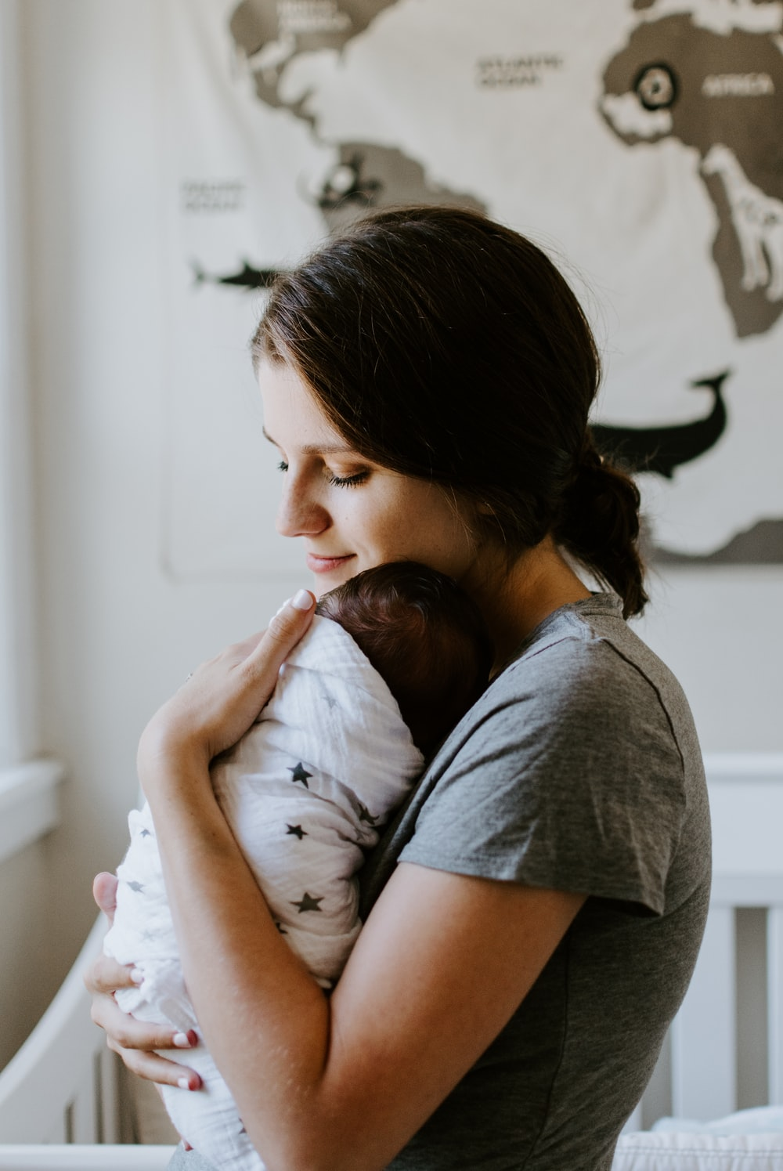
It feels like a long time since my children were small enough to be carried in such a way that they could rest between my shoulders! But I still remember that sense of peace that they and I experienced in that posture. I love this simple verse from the book of Deuteronomy. It comes when Moses, at the end of his life, speaks a blessing over the people of Israel and this is the blessing that he pronounces over Benjamin. Know today that you too are the beloved of the Lord, and so this verse is an invitation to you to rest in the Lord. The verb to rest comes twice here. It is a critical Christian discipline, and yet one that we struggle with so often. It is not speaking primarily about the kind of rest that you find at the end of the day when you sink into bed with a good book, or put your feet up in front of the telly (although those are good too!). It is talking about the deep rest that comes from knowing that you are loved for eternity by the Creator of the Universe, that it doesn’t all depend on you, knowing that He understands all our weakness and that He is our perfect heavenly Father who carries us through every storm, if we will let Him. We can trust Him.

Father we ask you to help us to rest secure in you today. Thank you that you offer us this kind of relationship with you – this kind of peace. In a world in turmoil, help me take up this posture today. I pray for those that I know who are struggling with fear or loss and ask that they will hear your invitation to rest today. In Jesus Name. Amen

Sarah Pix

