Daily Prayer & Encouragement - Thursday 17th December

Reading - Luke 1:18-19, 34-38

Zechariah asked the angel, ‘How can I be sure of this? I am an old man and my wife is well on in years.’ The angel said to him, ‘I am Gabriel. I stand in the presence of God, and I have been sent to speak to you and to tell you this good news. And now you will be silent and not able to speak until the day this happens, because you did not believe my words, which will come true at their appointed time.’
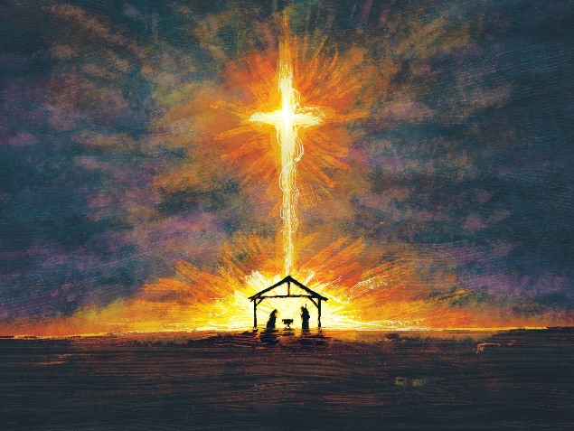
‘How will this be,’ Mary asked the angel, ‘since I am a virgin?’ The angel answered, ‘The Holy Spirit will come on you, and the power of the Most High will overshadow you. So the holy one to be born will be called the Son of God. Even Elizabeth your relative is going to have a child in her old age, and she who was said to be unable to conceive is in her sixth month. For no word from God will ever fail.’
‘I am the Lord’s servant,’ Mary answered. ‘May your word to me be fulfilled.’ Then the angel left her.

Encouragement

Whenever I read Luke chapter 1, I’m struck by the responses given by Zechariah and by Mary when Gabriel tells them about the children they will soon have. As we read their responses on paper, they appear very similar. They both say, “How can this happen?” and these seem to be reasonable responses, in human terms. Elizabeth was old, Mary was, indeed, a virgin.
Yet there must have been a difference, maybe in tone of voice but definitely in state of heart. Zechariah spoke with disbelief; Mary spoke with wonderment. And so Zechariah was struck dumb (and, it would appear, deaf as well), whilst Mary was blessed.
There are similar examples in the Bible; Sarah laughed when told she would have a son; Hannah went away from the tabernacle believing.
It makes me wonder how I would respond to a message from God telling me that Carrie-Anne and I would have a child by the end of 2021! I would love to think I’d respond with acceptance, but to be honest, I’d probably be much more like Zechariah and doubt it to be possible. But with God, all things are possible.
Of course, it’s not just about having children; it’s about any task that God gives me (look at how many signs Gideon asked for in Judges 6 & 7 rather than just believing). I want to be open to God, to believe He can do anything and to follow His plan for my life.

Prayer
Father, I believe. Please help me with my unbelief. Help me be like Hannah and Mary rather than Sarah and Zechariah. Amen
Andrew Harmer

